Introduction to Cloud Solutions Lab Report

Use this template to document your work as you complete the lab assignment in QA.

# Your Information

Your Name: Mahlon Sutton

Lab Title: Debugging and Provisioning AWS S3

# Instructions

Follow the instructions to answer the questions related to the lab and add the required screenshots. Submit your completed report following the instructions in Canvas.

## Section Forking an Existing Template from GitHub

1. **Step 5 Screenshot:** Forked S3 repository

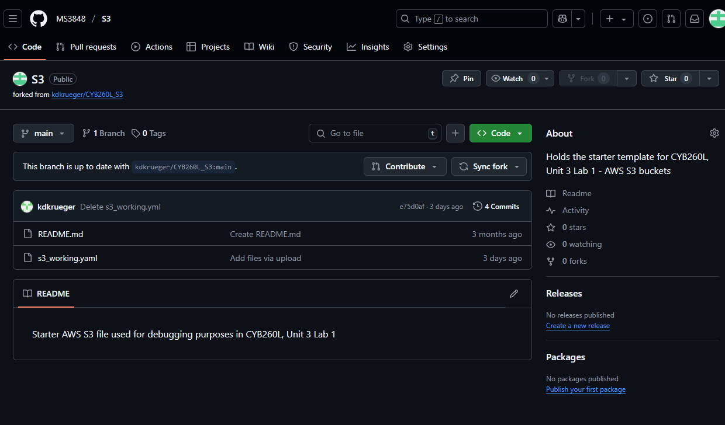

## Section Cloning a GitHub Repository

2. **Step 5 Screenshot:** s3_working.yaml template

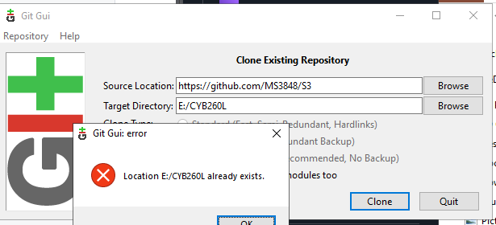

## Section Validating an AWS S3 CloudFormation Template

3. **Step 13 Screenshot:** Template successfully imported with S3 URL

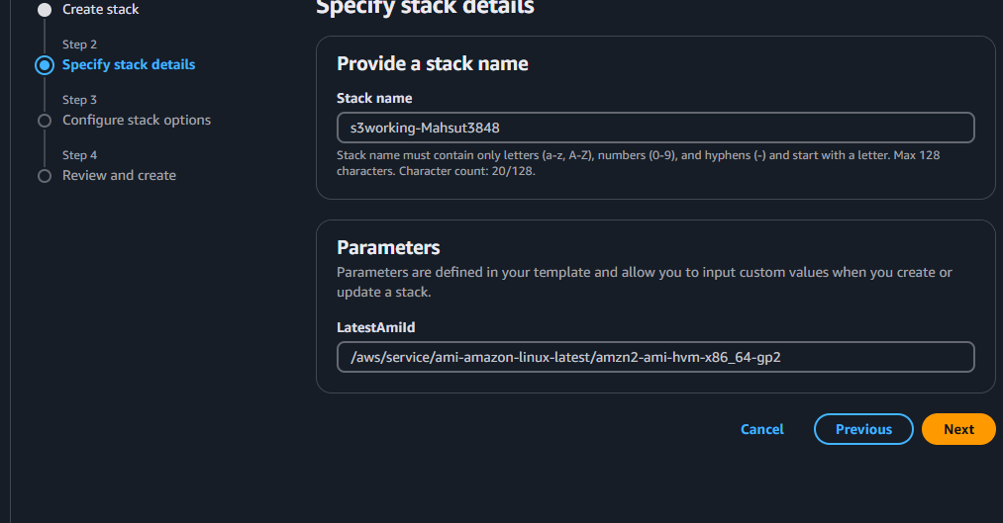

4. **Step 15 Screenshot:** s3working_studentID stack

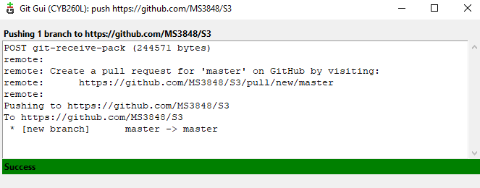

5. How many bugs did you encounter before your template was validated?

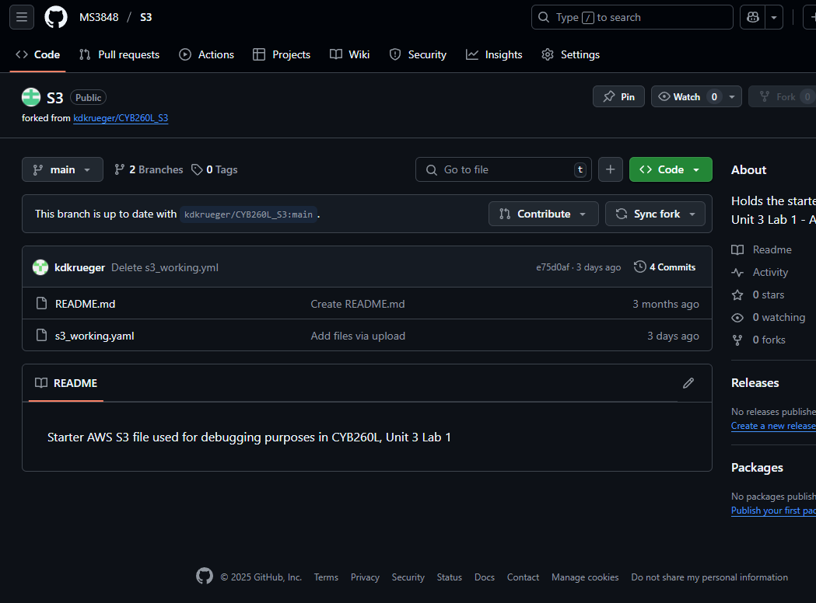

6. Describe each of the bugs inside your template file and the steps you took to resolve them.

## Section Committing Your Template File Changes to GitHub

**7. Step 11 Screenshot:** GitHub push results

**5. Step 13 Screenshot:** master branch contents